ZEN class JS B27 WE day4 task:

1. How to compare two JSON have the same properties without order?

* 1. var obj1 = { name: "Person 1", age:5 };
  2. var obj2 = { age:5, name: "Person 1" }

JS code:

var obj1 = { name: "Person 1", age: 5 };

var obj2 = { age: 5, name: "Person 1" };

let countObj1 = 0;

let countObj2 = 0;

console.log("------------------------------------------------------");

console.log("comparing all keys and their values of obj1 to obj2");

for (key in obj1) {

if (key in obj2 && obj2[key] == obj1[key]) {

console.log(`${key} is present in both objects and with same value ${obj1[key]}`);

countObj1 += 1;

}

}

console.log(`total number of keys in obj1 is ${countObj1}`);

console.log("------------------------------------------------------");

console.log("comparing all keys and their values of obj2 to obj1");

for (key in obj2) {

if (key in obj1 && obj2[key] == obj1[key]) {

console.log(`${key} is present in both objects and with same value ${obj2[key]}`);

countObj2 += 1;

}

}

console.log(`total number of keys in obj2 is ${countObj2}`);

console.log("------------------------------------------------------");

if (countObj1 == countObj2) {

console.log(`both objects have obj1 and obj2 are having same properties`);

}

wdwd

Output:  
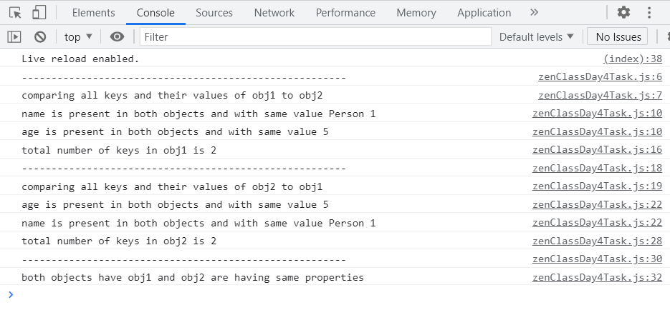

2. Use the rest countries API url -><https://restcountries.eu/rest/v2/all> and display all the country flags in console

JS code:

var newRequest = new XMLHttpRequest();

//we will send a instruction by applying on load

newRequest.onload = function () {

if (newRequest.status >= 200 && newRequest.status <= 400) {

var x = JSON.parse(newRequest.response);

//console.log(x);

for (key in x) {

let k = x[key].flag;

console.log(k);

// console.image(k[100]);

// console.log("%c ", "font-size:300px; background:url(k)");

}

} else {

console.log(this.responseText);

}

};

//create and send some request to api:

//get, post, put delete funtions

newRequest.open("GET", "https://restcountries.eu/rest/v2/all");

newRequest.send();

Output:  
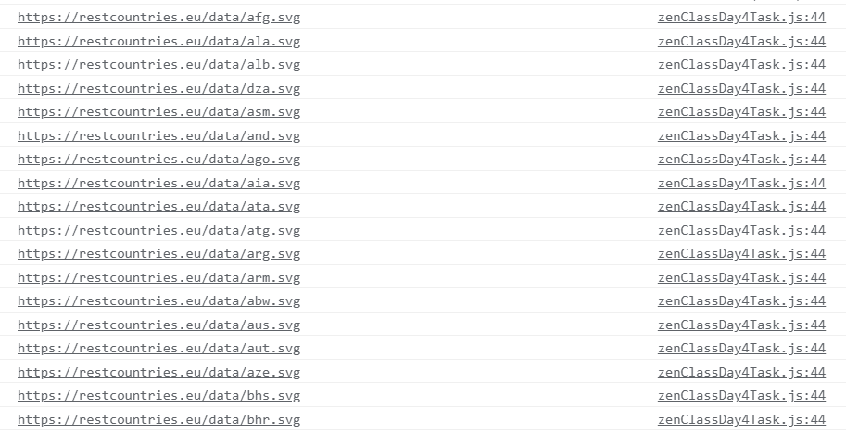

3. Use the same rest countries and print all countries name, region, sub region and population

var newRequest = new XMLHttpRequest();

//we will send a instruction by applying on load

newRequest.onload = function () {

if (newRequest.status >= 200 && newRequest.status <= 400) {

var x = JSON.parse(newRequest.response);

//console.log(x);

for (key in x) {

console.log(

`countrys name is ${x[key].name}, present in the region ${x[key].region}, in the subregion ${x[key].subregion}, with population of ${x[key].population}`

);

console.log("------------------------------------------------");

}

} else {

console.log(this.responseText);

}

};

//create and send some request to api:

//get, post, put delete funtions

newRequest.open("GET", "https://restcountries.eu/rest/v2/all");

newRequest.send();

Output:  
